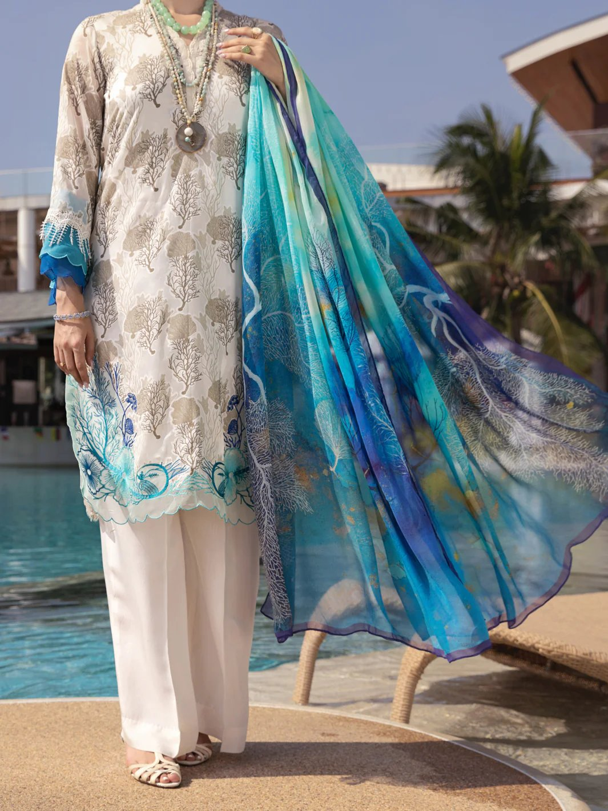

# BLUE COTTON VISCOSE SILK 2 PIECE STITCHED - ALCR-2PS-LKS-1022

Regular priceRs.9,910.00

ADDITIONAL INFO

|  |  |
| --- | --- |
| Color | Blue |
| Pieces | Comrade - 2 Piece Collection |
| Fit Type | — |
| Fabric | Cotton Viscose, Silk, |
| Season | — |
| Disclaimer | Due to the photographic lighting & different screen calibrations, the colors of the original product may slightly vary from the picture. |